Web-Talk, June 7, 2018, 6 pm
Religious Pluralism in Israel
with Shira Sasson Furstenberg

An important aim of the New Israel Fund is the securing of religious pluralism in Israel. Despite impressive progress during the past years the current government has caused a number of setbacks. Shira Sasson Furstenberg will give an appraisal of the current situation and explain the contribution of the NIF to the achievements and ongoing struggle for religious pluralism and religious freedom in Israel.

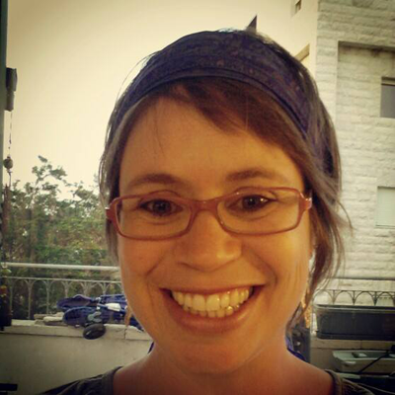

Shira Sasson is chief of Staff at NIF Jerusalem. Previously, she served as a grants and program officer at the NIF and Shatil for ten years, focusing on the issues of Jewish pluralism and religious freedom.
Shira Sasson was the director of the Jewish Pluralism Watch, the Masorti (Conservative) Movement's Knesset watch which monitors, interprets and publicizes the positions, statements, and voting records of Knesset Members and other elected officials on all issues of democracy, religion and the state. She also served as the director of iRep – Israel Religious Expression Platform, at the Jewish Federations of North America. In this capacity, she worked on impacting a range of issues related to increasing religious diversity in Israel with the goal to advance meaningful change to the status quo and to facilitate a range of legally-recognized options for marriage in Israel. Shira also worked at the Knesset research and information center.
Shira Sasson holds BA and MA degrees in sociology and anthropology from the Hebrew University. She lives in Jerusalem with Yair and their three children and is an active member in Hak’hel – the Baka egalitarian minyan.

